**Design & Technology**

**

**Renewable energy**

**Materials required for questions**

* Pencil
* Rubber
* Calculator

**Instructions**

* Use black ink or ball-point pen
* Try answer all questions
* Use the space provided to answer questions
* Calculators can be used if necessary
* For the multiple choice questions, circle your answer

**Advice**

* Marks for each question are in brackets
* Read each question fully
* Try to answer every question
* Don’t spend too much time on one question

**Good luck!**

**Q1.** What type of renewable energy is shown in the picture below?

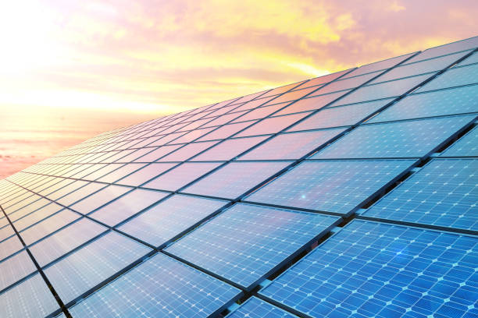

**A** Solar

**B** Biomass

**C** Thermal

**Q2.** What type of renewable energy is shown in the picture below?

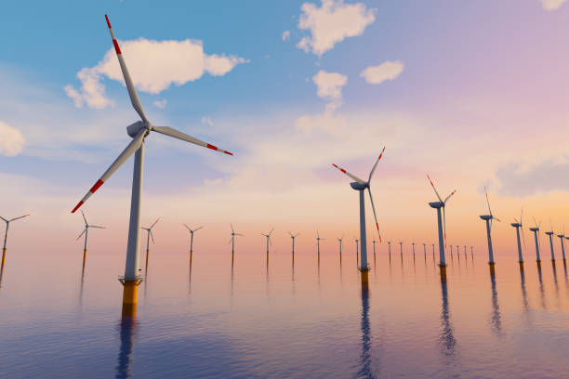

**A** Wind

**B** Biomass

**C** Hydroelectric

**Q3.** Which one of the following is a renewable resource?

**A** Natural gas

**B** Oil

**C** Water

**Q4.** What is a key disadvantage of solar power?

**A** It produces radioactive waste

**B** It cannot generate large amounts of electricity

**C** It only works during daylight hours

**Q5.** What is the main advantage of hydroelectric power?

**A** It has no environmental impact

**B** It can provide continuous, reliable energy

**C** It is the cheapest renewable to install

**Q6.** Why might biomass energy be considered carbon-neutral?

**A** The CO₂ emitted is offset by plants’ CO₂ absorption

**B** It stores carbon underground

**C** It releases no CO₂ when burned

**Q7.** Explain how solar power and wind power generate electricity, and give one limitation of each **(4 marks)**

**Q8.** Compare hydroelectric power and tidal power as renewable energy sources, listing one advantage and one disadvantage of each **(4 marks)**

**Answers**

**Q1**. A

**Q2**. A

**Q3**. C

**Q4**. C

**Q5**. B

**Q6**. A

**Q7.**

Mark Scheme:

Solar power explanation (1 mark):

* Photovoltaic (PV) cells convert sunlight directly into electricity OR
* Concentrated solar power (CSP) uses mirrors to heat fluid, producing steam to drive turbines.

Wind power explanation (1 mark):

* Wind turns turbine blades, which spin a generator to produce electricity.

Solar limitation (1 mark):

* Only works during daylight hours / cloudy weather reduces efficiency / requires large land area.

Wind limitation (1 mark):

* Unreliable in low-wind conditions / noise and visual pollution / potential harm to birds.

**Q8.**

**Hydroelectric advantage (1 mark):**

* Provides reliable, continuous power / large-scale energy storage possible / low operating costs.

**Hydroelectric disadvantage (1 mark):**

* Flooding land destroys habitats / high construction costs / droughts affect output.

**Tidal advantage (1 mark):**

* Predictable energy source (follows moon cycles) / long lifespan / low greenhouse gas emissions.

**Tidal disadvantage (1 mark):**

* High upfront costs / limited suitable locations / potential impact on marine ecosystems.